**SOS Save our Curlews Campaign**

**Project results 2025**

The SOS Save our Curlews Campaign has again been working with Community Wildlife groups in the Strettons and Oswestry areas (Tanat to Perry and Three Parishes – Weston Rhyn, St Martins and Gobowen). Project work aimed to find as many Curlew nests as possible, and put an electric fence around them to protect the eggs from predators, then radio-tag the chicks that hatch, and track them, to find out how they use the landscape, and what happens to them.

**© Terry Moore**

**© Steve Hughes**

In the Strettons area, the CWG bird survey located 10 pairs of Curlew. This included a pair near Betchcott (a regular site, but not in our core area), and pairs near Hughley and Stanton Long, which both nested in the CWG area this year, but which often nest just outside it. The SOS project found four nests, all of different pairs, and fenced them. At one nest, four chicks hatched and were radio-tagged and tracked, but they were all predated within a few days. No chicks hatched from eggs in the other three fenced nests – two were trampled by cattle or sheep, and avian predators, probably crows, took the third clutch.

Two chicks were seen near another nest at Stanton Long, but they apparently only survived for a couple of weeks rather than the five weeks they need to fledge. No evidence was found that any of the other five pairs got as far as eggs hatching.

In previous years, a few chicks died of natural causes, but most were predated. Since the project started in the Strettons area, in 2021, 19 nests have been found and fenced, and eggs hatched in 10 of them, but not one of the 32 radio-tagged chicks from those nests went on to fledge.

In the Oswestry area, 10 pairs were found, five in the Tanat to Perry (Oswestry south) CWG area and another five in the Three Parishes (Oswestry north) CWG area. Six nests were found, one fewer than last year’s excellent result, but much better than the one found in the first year (2023).

* Four were found in the south area, one of which was a relay. The relay, and the other two nests, all hatched chicks, eight altogether, but all were predated, four within 6 days, two within about 20 days and two after 26 days. Most of the predators are unknown, but crow, Buzzard and domestic cat almost certainly accounted for one each. One adult was caught and colour-ringed. One landowner refused permission to look for the nest of one pair.
* In the Oswestry north area, two nests were found. The landowner refused permission to fence one (unlike last year), and the eggs were predated within three weeks. A change-over of incubating bird was witnessed at a second site, but the nest was predated before permission could be obtained to fence it. The predators are unknown.

It is often difficult working out what has predated a Curlew chick, if no signal is received from a previously tracked radio tag. The lack of signal could be because the tag has been taken underground into a fox den (the signal will not travel far through earth), or because a raptor has pulled the aerial off. Tags taken up to nests are easier to find because they transmit further by virtue of their elevated location. A tag taken by a crow may end up in a nest or in a pellet, although more usually it will be pulled off before consumption. It will still transmit, but only if the aerial is not damaged

In the Oswestry north area, there is definitely one, probably two, fox dens near Baker’s Hill. There were substantial numbers of corvids in the fields surrounding the nest at Bromwich, and near Maesbury nest there were plenty of corvids also but also several cats close by.

The intensive searching of the Oswestry Racecourse / Baker’s Hill area confirmed the presence of four pairs of Curlew, the same as last year, whereas the Wildlife Group survey three years ago was unable to separate the numerous records into more than two pairs. The fifth pair, located by Three Parishes CWG Bird Survey, was on the western edge of SJ23X, near Wern. There were several records in March and April, but none after 3 May, suggesting an unsuccessful breeding attempt there.

At the current rate of population decline across Shropshire, half the Curlew population will disappear in the next 12 years, and it will disappear altogether in 23. We don’t want that to happen We need to understand the reasons for poor chick survival, to work out an effective conservation strategy.

The project has operated for five years in the Strettons area. During that time 19 nests have been found and fenced, and 32 chicks have been tagged and tracked, but no tagged chicks have fledged. The Community Wildlife Group continued to monitor the other pairs whose nest was not found (a combined total of 40-41 pairs over the five years) and there is no evidence that any chicks hatched at all in this period, a very depressing result.

Only three year’s work have been carried out in the Oswestry area, and only one nest was found and fenced there in 2023, but five nests were fenced in 2024, and three in 2025. Over the three years, 13 chicks hatched and were radio tagged. Although none fledged in 2025, two got to within a week of doing so, and in 2023 one chick fledged and was colour-ringed, and chicks in two other broods probably fledged. The project needs to continue for at least one more year in that area before it is possible to draw any firm conclusions.

The survival period of all the chicks except two was only a small proportion of the 35 days or so that a Curlew chick has to survive to be able to fly. We believe that the evidence shows that predation pressure on Curlew chicks is far higher than the naturally-sustainable level, because of the masses of additional food put out for predators and scavengers in the UK in the form of 60 million gamebirds (mainly Pheasants, but also partridges and ducks) put out each year for shooting. Only one-third of these gamebirds are actually shot, and most of the others are easy prey. Stoats, as well as the more frequently encountered foxes, corvids, and birds of prey, all benefit from gamebird release.

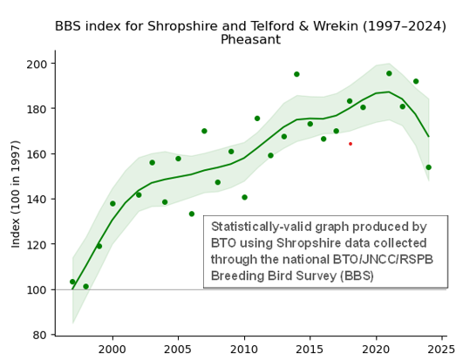

It is estimated that more than two million gamebirds were released in Shropshire alone in 2018 alone. Few survive until the following breeding season, but they have been sufficient to drive a massive increase in the number of pheasants recorded in Shropshire since 1994 as part of the national Breeding Bird Survey (BBS). However, fewer Pheasants were released in 2020, when covid-19 restrictions limited the number of shoots that operated, and bird flu outbreaks in France since then have limited the number of pheasant chicks imported into Britain to be reared and released. As shown in the BBS Index chart, produced by BTO, this has led to a reduction in pheasants available to predators in 2024, although it is still nearly 50% higher than in 1997. The number of pheasants available to feed predators, and maintain their excessive population

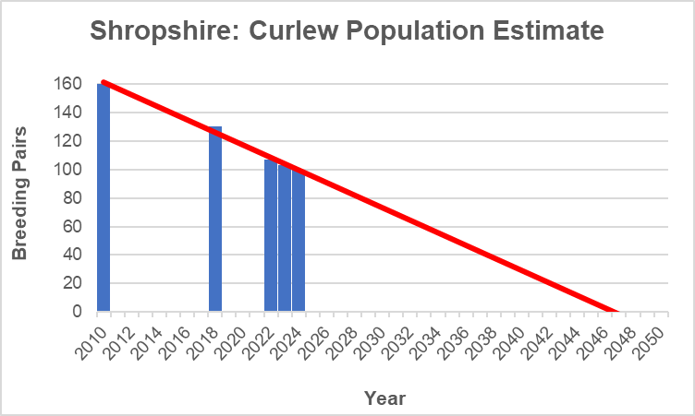

The Shropshire Curlew population is regionally and nationally important (there are only an estimated 500 pairs of Curlew in southern England, south of a line from the Dee estuary to The Wash, and Shropshire holds around one-fifth (20%) of them). However, for the first time the estimated County population has fallen to below 100 pairs, and, at the current rate of decline, the County Curlew population will halve in 12 years, and virtually disappear in 23 years, in 2047. The chart will be updated when the results of the CWG surveys for 2025 are analysed.

Almost all the farmers who owned the land on which the Curlews nested or fed were supportive of the project, and gave permission to look for the nests and fence them. However, one landowner refused permission to look for nests, one refused permission to fence a found nest, and a third only agreed to a smaller fence. Thanks to all of them who gave permission for the project to operate.

Apart from the SOS funding, the project work was largely financed by donations to the SOS appeal, so thanks to all contributors. Obtaining grant funding is becoming increasingly difficult. For the first time in many years, the Shropshire Hills Protected Landscape Conservation Fund did not approve a grant application, and Stretton Focus, which has funded the project twice before, also declined an application.

The project started in 2018, and most work up until 2022 was carried out in the Upper Clun and Clee Hill areas. A full report of results 2018-22 can be found on the SOS website [www.shropshirebirds.com/save-our-curlews/](http://www.shropshirebirds.com/save-our-curlews/) Over that period, 31 nests were found and fenced, and the fences were found to be 74% effective in protecting the eggs. A total of 61 chicks were tagged and tracked: only 5-6 fledged, less than half the number needed for a sustainable population. The average survival period for these chicks was only 6.13 days. More than half of the chicks were taken by foxes. Eight died of natural causes, and the remainder were taken by avian predators. None were lost to agricultural activity.

The project has operated in the Strettons and Oswestry areas in the three years 2023-25. In the Strettons area, fences were 53% effective in protecting the eggs in 19 nests over five years, and in the Oswestry area 56% effective in protecting 9 nests (so far). One brood from an unfound nest was lost to silage cutting in the Oswestry area in 2023, but all of the 26 chicks that have been radio-tagged in the three years in the two areas have been predated. None fledged, and none were lost directly to agricultural activity. This reinforces the conclusion in the 2022 report that productivity is less than half of that needed for a stable population, and predation is the main driver of decline.

A summary of the project results for each year since 2018, in all the five areas we have worked in, is appended below. The detailed results for each area can be found on the SOS website https://www.shropshirebirds.com/index/bird-conservation/save-our-curlews/

Leo Smith

SOS Save our Curlews project coordinator

leo@leosmith.org.uk

August 2025

**Appendix: SOS Curlew Campaign: Summary of Results 208-25**