RSPB review of raptor persecution in Shropshire

The publication An atlas of the breeding birds of Shopshire (Deans, P. et al. 1992) make reference to an RSPB publication, Death by Design, which looked at the persecution of birds of prey and owls in the UK between 1979 – 1989. During that period, Shropshire had the second highest number of pesticide abuse incidents of any county in England, after North Yorkshire.

Since that publication the RSPB has produced an annual Birdcrime report. This remains the only centralised source of incident data for birds of prey persecution offences in the UK and includes details of related prosecutions. All reports of possible offences against birds of prey are recorded, assessed and placed in one of three categories.
- Unconfirmed: The circumstances indicate an illegal act has possibly taken place.
- Probable: The circumstances indicate that by far the most likely explanation is that an illegal act has taken place.
- Confirmed: The circumstances indicate an illegal act has taken place. These incidents are typically substantiated by evidence such as post-mortem or toxicological analysis (eg shooting and poisoning cases), or reliable eyewitness evidence.

Whilst the collation of persecution data and prosecution of offenders remains vitally important, it can never tell the full picture as only a small of fraction of incidents will ever be discovered and recorded. Furthermore, only a very small percentage of reported cases will ever result in court proceedings. The long term monitoring of UK raptor populations will continue to form the essential baseline to inform government and decision makers how effective legislation and conservation measures are for particular species. In recent years a number of peer-reviewed scientific papers have been published which clearly spell out the impact that persecution continues to have on a range of species, particularly on upland areas of England and Scotland managed for driven grouse shooting.

Since Death by Design, a review of the raptor persecution data for the following 25 years from 1990 to 2014 reveals the following.

Report type | UK | Shropshire (% UK total)
Total reports of shooting and destruction involving raptors | 4768 | 58  (1.2%)
Confirmed shooting and destruction incidents | 1293 | 24  (1.9%)
Totals reports of poison related incidents involving raptors | 1802 | 30  (1.6%)
Confirmed poison related incidents | 1133 | 15  (1.3%)

Shropshire has an area of 3,487 square kilometres, about 1.4% of the total UK land area. Based on land area, levels of raptor persecution in Shropshire appear about average for the UK. However, the highest levels of raptor persecution are typically associated with counties where a significant area of the land is devoted to driven grouse shooting. Consequently, Shropshire figures will be above average when compared with other counties which also have no driven grouse shooting interests. Confirmed persecution incidents in Shropshire during this period include: -
- The shooting of numerous common buzzards, five peregrines, and singles of osprey, red kite and goshawk.
- The poisoning of nine common buzzards, four peregrines and, most recently, a red kite in 2014.
- A few incidents relating to the use of illegal traps to take raptors.
In addition to raptor persecution incidents, at least 13 peregrine nest sites have been robbed of eggs or chicks (mainly believed connected to falconry interests), and at least three goshawk sites have been robbed of eggs. The taking of one of the goshawks clutches from a Shropshire site in 1994 led to the prosecution of a falconer and his partner.
In order to maintain these long term datasets of raptor persecution incidents the RSPB rely heavily on the monitoring work of many Raptor Study Groups around the UK. The RSPB would like to acknowledge the assistance provided by the Shropshire Peregrine Group in relation to the data gathered in the county.

Whilst North Yorkshire still retains its place as the worst county in England for raptor persecution, it does appear there has been a welcome reduction in confirmed pesticide offences in Shropshire since the Death by Design report. Encouragingly, the situation for raptors across much of lowland UK has significantly improved since the time of the last Shropshire bird atlas, with dramatic increases in the range and population of common buzzard and red kite.

Looking at the profile of those convicted of these offences since 1990 shows that around three quarters had game shooting interests, the majority being gamekeepers.
Occupations and interests of 172 people convicted of bird of prey persecution related offences 1990 to 2014
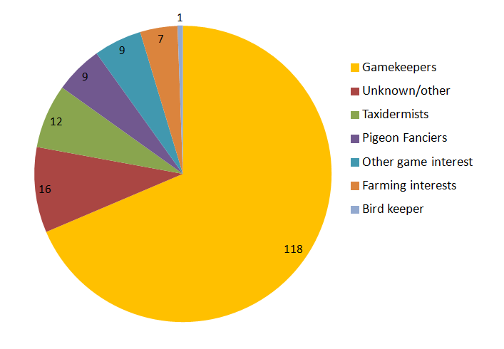
Three of these prosecutions have been in Shropshire. In 2007, a gamekeeper was convicted for the possession and use of pesticides following an incident involving the poisoning of two buzzards. He received a Conditional Discharge.

In 2008, two gamekeepers from a large commercial pheasant shooting estate in Shropshire pleaded guilty to a range of offences. This included the shooting of buzzards, use of illegal traps and killing badgers. Both men got suspended jail sentences, an indication of how seriously the court took this case, which attracted national media attention. During the West Mercia Police and RSPB investigation a ‘vermin diary’ for 2007 was seized from one of the men. In addition to birds and animals that they were lawfully controlling, the records indicated that during part of 2007 a total of 102 common buzzards, 40 ravens and 37 badgers had been illegally killed. This provides a graphic and disturbing insight into the levels of illegal persecution that are still taking place on some game shooting estates in the UK.

During 2014, a cage traps illegally baited with two live domestic quail was found by an active pheasant release pen near the Stiperstones. This was a typical ‘hawk trap’ and believed intended for accipiters and buzzards. A local gamekeeper was covertly filmed by the RSPB attending to the trap on a number of occasions. He appeared at court in relation to this in 2015, but was acquitted in relation to these offences after the court refused to accept the surveillance footage.

There have been other significant events since 1990 which have had a bearing on the raptor persecution problem. The Police Wildlife Crime Officer’s (WCO) network, which the RSPB helped start in the 1980’s, has expanded significantly. Nearly all police forces now have at least one WCO, with some in a full time role.

In 1990, RSPB used covert surveillance for the first time to photograph a gamekeeper in the act of setting a pole-trap at a pheasant release pen; he was later prosecuted. With the advent of video cameras this has proved a very useful tool in gathering the necessary evidence and over 25 further individuals have been convicted as a result of RSPB covert surveillance.

In 2000, the government published the Report of the UK Raptor Working Group. This again highlighted the continuing impacts of persecution on a number of species. In 2006 the National Wildlife Crime Unit (NWCU) was launched, a small dedicated statutory agency set up to tackle wildlife crime. In 2009, the government announced its six national wildlife crime priorities which included ‘Raptor Persecution’ with a focus on five species (golden and white-tailed eagles, hen harrier, red kite, peregrine and goshawk). The recently published BTO ‘Bird Atlas 2007-11’ shows that Shropshire remains an important county for the goshawk. Unfortunately, this is a species which appears to have made little national progress since the time of the last Shropshire bird atlas, and remains absent from large areas of suitable habitat across the UK.

In conclusion, in common with the rest of the UK, it is clear that raptor persecution problems remain in Shropshire. However, levels of pesticide abuse appear to have reduced and it is hoped the county can help act as a stepping stone for the future expansion of the goshawk population into other parts of the UK.

Guy Shorrock
RSPB Senior Investigations Officer

